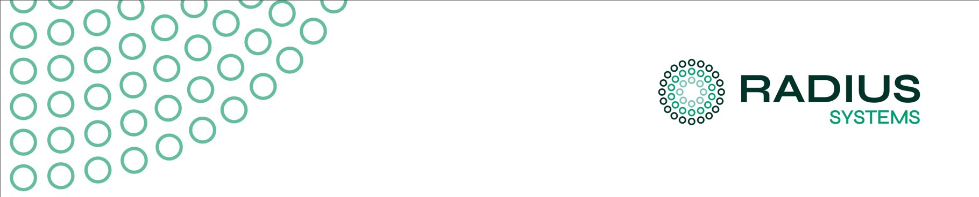

INSTRUCTIONS FOR USE

SC80 LIGHT BLUE POLYETHYLENE PIPE
In respect of
USE IN PUBLIC WATER SUPPLIES REQUIRING REGULATION 31(4)(a) APPROVED LISTING

ISSUE NUMBER 003
ISSUE DATE 28th January 2026
CONTACT technical.support@radius-systems.com
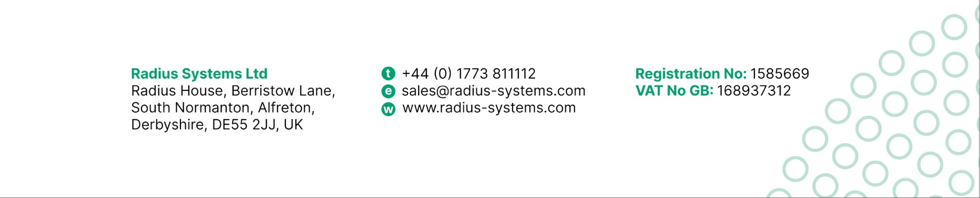
[1] SCOPE OF THE PRODUCT

The product is a polyethylene pipe conforming to BS EN 12201-2. It has an external light blue colour meeting NJUG Guidance on identification of underground assets denoting the pipe is intended for the distribution of potable quality drinking water.

[1.1] PRODUCT DESCRIPTION
The product is formed of two layers of polyethylene that are fused together during extrusion to form a pipe. The inner layer in full contact with drinking water is carbon black stabilised polyethylene. The outer layer is formed of light blue pigmented polyethylene. The general construction and approved compounds for the product are shown below.

The materials used for the product are classified as PE80 according to BS EN ISO 9080 and have a long term strength classification (MRS) of 8 MPa, based on a design point of 50 years/20°C. It is the responsibility of the network designer to assess the application and set the maximum pressure rating of the pipe network in use.

Drinking Water
Here
Light Blue Colour Identification Layer
Approved Compounds | Borsafe ME3444

Black Core Layer In full contact
Approved Compounds | Total 3802B
Approved Compounds | Borsafe ME3440

The product is approved for manufacture and supply from the following address(es):
- Radius Systems Limited, Hilcote Plant, Berristow Lane, South Normanton, Derbyshire, DE55 2JJ

[1.2] PRODUCT DIMENSIONS
This IFU is specific to pipe products having an outside diameter range from 20mm to, and including, 63mm with dimensions and tolerances described in BS EN 12201-2 tables 1 & 2.

The product having the greatest surface area to volume ratio in contact with drinking water in the range is size 20 SDR 11. The declared surface area to volume ratio is 2.6 cm⁻¹ or 2597 cm²/litre.

[1.3] RESTRICTIONS IN USE
In normal use, the pipe is expected to have a service life more than 100 years. The pipe is intended for below ground use. It shall not be used above ground unless it is installed in a protective sleeve that always prevents contact with sunlight and consideration is given to elevated operating temperature.

The product is not suitable for use in proximity to desalination plants where the treated water is discharged at higher temperatures and with elevated levels of (e.g.) chlorine or bromine unless consideration is given to a reduced lifetime in use.

Pipe may be used for works above ground as a temporary measure, for example as a bypass, provided it is within its shelf-life date. If used after this date then allowance should be made for degradation of the outer colour shell, i.e. take steps to evidence suitability of the intended operating pressure.

The product is not suitable for use in land designated as brownfield (i.e. previously used in an industrial and/or commercial setting). Land of this type, often with hydrocarbon residues and/or chemical contamination shall use barrier pipe systems suitable for this soil type.

[2] CONDITIONS OF USE

[2.1] Storage Condition & Shelf Life
The product is suitable for storage outside in all regions of the United Kingdom for a period of 2 years from the date of manufacture. The date of manufacture is shown on the print line, repeated every 1 metre, on the side of the pipe.

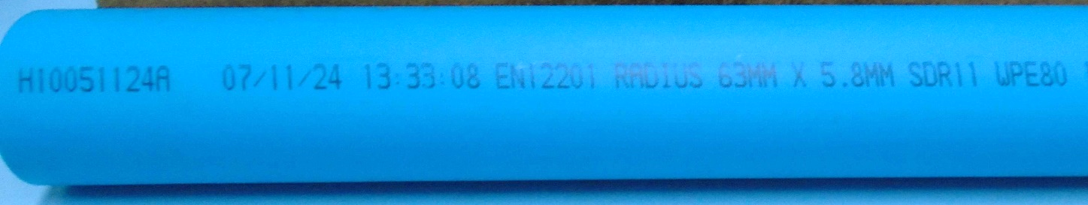

Date of manufacture Product standard Manufacturer

Product shall be stored off the ground to prevent hard objects indenting the materials and causing point load, puncture of abrasion damage. In relation to storage:
- Product shall be secured to prevent it being blown over, falling or slipping, or otherwise moving in an uncontrolled manner
- Product should be stored in a manner that it can subsequently be picked and lifting again without causing abrasion damage or requiring an unsafe action

Steps shall be taken to prevent contamination of the product likely to lead to a biological hazard, including taste and odour issues in future use:
- Product shall be stored with packaged end caps fitted to prevent, for example, rodent entry/faecal droppings and/or other biological hazards entering the pipe.
- Product shall be stored in such a way that it is not subject to flooding following surface water events, packaged endcaps are insufficient/not intended to resist floodwater entry
- Product shall not be stored in an area where it is subject to prolonged exposure to exhaust fumes from fixed or mobile plant
- Product shall not be stored in an area where chemicals, including their fumes and vapours, will condense or otherwise be absorbed into the pipe surface

[2.2] Unloading Requirements
The water company or its contractor is reminded of the need to use a suitable and safe system of work for the unloading of pipes and to identify the responsible party applicable to each stage of the supply chain and prior to commencement of operations.

Any attachment to the pipe, in coil or stick form, shall be suited to:
- Not causing localised kinking or indentation collapse of the pipe form, particularly in regard to the lifting of coils
- Not causing abrasion damage where sticks, or stick packs are inadequately supported resulting in the ends sagging and dragging on the ground as they are picked up/set down
- Not causing abrasion damage where the lifting machine is connected, whether this be use of forked vehicles with specialist attachments or cranes
- Before lifting products from the vehicle, a visual check should be made that all the packaging straps remain intact and have not moved or failed in transit

Pipe shall be inspected immediately after unloading to verify at least the following attributes:
- The correct pipe and quantity have been delivered
- For coiled pipe, all safety straps securing the coil are intact and undamaged
- For all pipe forms, to confirm the pipe is not damaged, emphasis on abrasion damage inspection
- For all pipe forms, to confirm packaging end caps are fitted
- That the product has been set down and supported off the ground

[2.3] Preparation Requirements
There are no additional preparation requirements.

[3] INSTALLATION GUIDANCE NOTES
All references to Information Guidance Notes (IGN) and Water Industry Specifications (WIS) are taken from, and the relevant references and documents can be found by reference to the WaterUK Standards Board website www.standards-board.water.org.uk.

[3.1] National Hygiene Water Card
Persons working with the product shall hold the National Hygiene Water Card (also known historically as the Blue Card). Requirements can be found by reference to www.eusr.co.uk awarding body.

[3.2] Network Construction Operations, Water
Persons leading the works on a construction site should hold an NCO Water registration in the class of ‘Skilled Worker’ covering main layer, repair and maintenance operations.

[3.3] Design
For design, the water company shall appoint and designate the authority covering the performance attributes of the pipe in service and the method of construction required to achieve their goals. The product is considered suitable for use with the following construction techniques subject to good practice being followed:
- Installation to an open trench, provide adequate bedding and side fill materials are used. For guidance see IGN 4-08-01 and WIS 4-08-02
- Direct to ground using impact moles or directional drilling, slip lining of an existing water main or pipe bursting, so called trenchless techniques provided:
  - Any hoses or tools passing through the pipe required by virtue of the technique are first cleaned/sterilised
  - Any pulling heads attached to the pipes are of the type that form a seal to the pipe and prevent soil or fluid entry/contact during the installation operation
- NOTE: Impact mole techniques that use PE pipe as a temporary air hose are not covered by this IFU. Taste, odour and microbiological assessment are needed to validate dry air/filtration specification.

[3.4] Jointing
The pipes are suitable for jointing using mechanical or electrofusion means. Pipes of the type and size covered by this instruction for use are not suitable for butt fusion jointing.

In the case of mechanical fittings, full end load bearing fittings (designated as Type 1 in IGN 4-01-02) should be used. Suitable fittings could conform to BS EN 12201-3 and/or BS 8561. In all cases, fittings shall conform to the requirements of Regulation 31(4)(b) of the Water Supply (Quality) Regulations. The manufacturers instructions shall be followed for the correct method of assembly. In addition (for mechanical fittings):
- Pipe ends and fittings shall first be cleaned of any physical contamination and then sprayed with a solution of 1000 mg/L free available chlorine as they are laid

In the case of electrofusion fittings, additional to the manufacturer’s instructions, the water company or its appointed contractors shall meet the requirements of WIS 4-32-08.

[3.5] Strength & Leak Tightness Testing
All new mains and services shall be inspected to confirm they are not leaking before being placed into service.

For all sizes, suitable methods of testing pipes are set out in WIS 4-01-03.

[3.6] Chlorination and Flushing
Chlorination and flushing shall be in accordance with publication “Principles of Water Hygiene’ published by WaterUK. The latest edition shall always take precedence.

For new mains and service pipes, the requirements of Annex TGN2 apply. Swabs are recommended to scrub the pipe bore followed by disinfection equivalent to 20 mg/L free chlorine maintained for a standing time of 16 hours, or an alternative achieving the same technical requirements. Attention is drawn to:
- For any pipe suspected of internal surface contamination, of any size, chlorinated swabs are first used to scrub and clean the pipe bore. “Service” sizes are included in this scope.
- For pipe sections forming repairs to existing pipeline networks, the requirements of TGN3 (Repairing Mains) apply
- For trenchless technologies, the requirements of TGN4 (Renovated Mains) apply in relation to sections using coiled pipe forms
- For temporary bypass and overground installations, the requirements of TGN6 (Temporary Overland Mains and Services) apply.

Users are reminded that chlorine is an oxidising fluid which affects the polyethylene pipe material. Where higher doses and/or exposure times are intended, save for the well known ‘super-chlorination’ of 50 mg/L for 30 minutes, water companies should collaborate with the manufacturer to verify the selected method does not adversely affect the material on the internal surface of the pipe.

After chlorination and flushing of the new mains and/or services a water sample should be taken and assessed in line with the adopting Water Companies acceptance procedures.

[3.7] Routine Checks on Performance in Operation
There are no maintenance actions specific to polyethylene pipe fittings and systems.

[4] DISPOSAL AND FATE OF THE PRODUCT
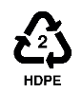

The product is a medium/high density polyethylene material and can be recycled.

In relation to packaging materials,
- Timber supports for stick packs are untreated and can be reused and/or recycled.
- Shrink wrap used for holding multiple coils in transit is LDPE polyethylene and can be recycled
- Security straps made of metal bands for coiled pipe can be recycled
- Security straps made of plastic or synthetic materials are not graded and should be landfilled.

During construction users are reminded of the need not to contaminate the environment and the specific requirement to prevent plastics entering water courses where their buoyancy means they move quickly through the environment, often to the sea. Offcuts and shavings should be bagging and disposed, not left on or in the workplace.

The long lifetime of polyethylene pipes in water distribution networks, of at least 100-200 years given UK operating parameters, means that end of life recovery has yet to be demonstrated. Subject to at least the following considerations, end of life recovery is an option:
- Where a biofilm exists, the main is first scrubbed with a foam swab in-situ
- As pipe is extracted or lifted the fittings are cut and removed
- As pipe is extracted the outer surface is reasonably cleaned to removed clumped soils and clays
- Pipe is cut and packaged to permit handling by a recycling company

[5] CHANGE CONTROL
Date of change | Rev Number | Notes
3-Sep-25 | 002 | Cl 3.2; amendment to set mandatory requirement for Reg 31(4)(b) small contact area as basis for acceptable fittings according to this IFU
28-Jan-26 | 003 | Cl 1.1; added additional material grade for core (inner) layer

END.

