Radius Systems - Pipe coil safety operations

Radius Systems provide polyethylene pipes in coiled format from 20mm to 180mm, in lengths ranging from 25m to 500m. Radius Systems provide service and mains pipe sizes in coiled format for the benefit of a longer length pipe installation without joints.

Details of pipe coil sizes can be found on Radius System’s website and also in our specific pipe product brochures. The process of forming the pipe lengths into coils pipes results in the packaged product containing an amount of stored energy, which is released when the securing pipe bands are cut and removed.

Therefore, it is recommended that the pipe coil is loaded into a purposely designed coil dispensing bag or coil trailer with appropriate safety features to safely dispense the pipe in a safe controlled process.

Personnel handling and installing pipes supplied in a coiled format should be trained and competent to do so and be aware of the hazards associated with this activity.

Service pipes
Pipe sizes 20mm to 40mm can be stored and dispensed from a coil dispensing bag, which has been specially designed to contain the pipe for dispensing. The service pipe coil must be placed inside the bag before any of the supporting bands are cut.

Radius systems guidance is that two persons should manage the pipe coil and dispensing bag, as follows: -
- Place the service coil onto soft ground or onto wooden blocks.
- Place the coil dispensing bag over the service pipe coil. The bag is elasticated so may require 2 people to manage the fitting over the service coil.
- Open the coil dispensing bag and work around the coil until the coil is within the bag
- Cut the pipe security bands as required
- One person should secure the pipe dispensing bag and carefully pay out the pipe, the 2nd person should hold the leading pipe tail and remove the required length of pipe. The metre marks on the pipe can be used for approximation.
- The pipe dispensed from the dispensing bag should be secured at both ends before the pipe is cut.
- Ensure the remaining service pipe remains within the dispensing bag until required.

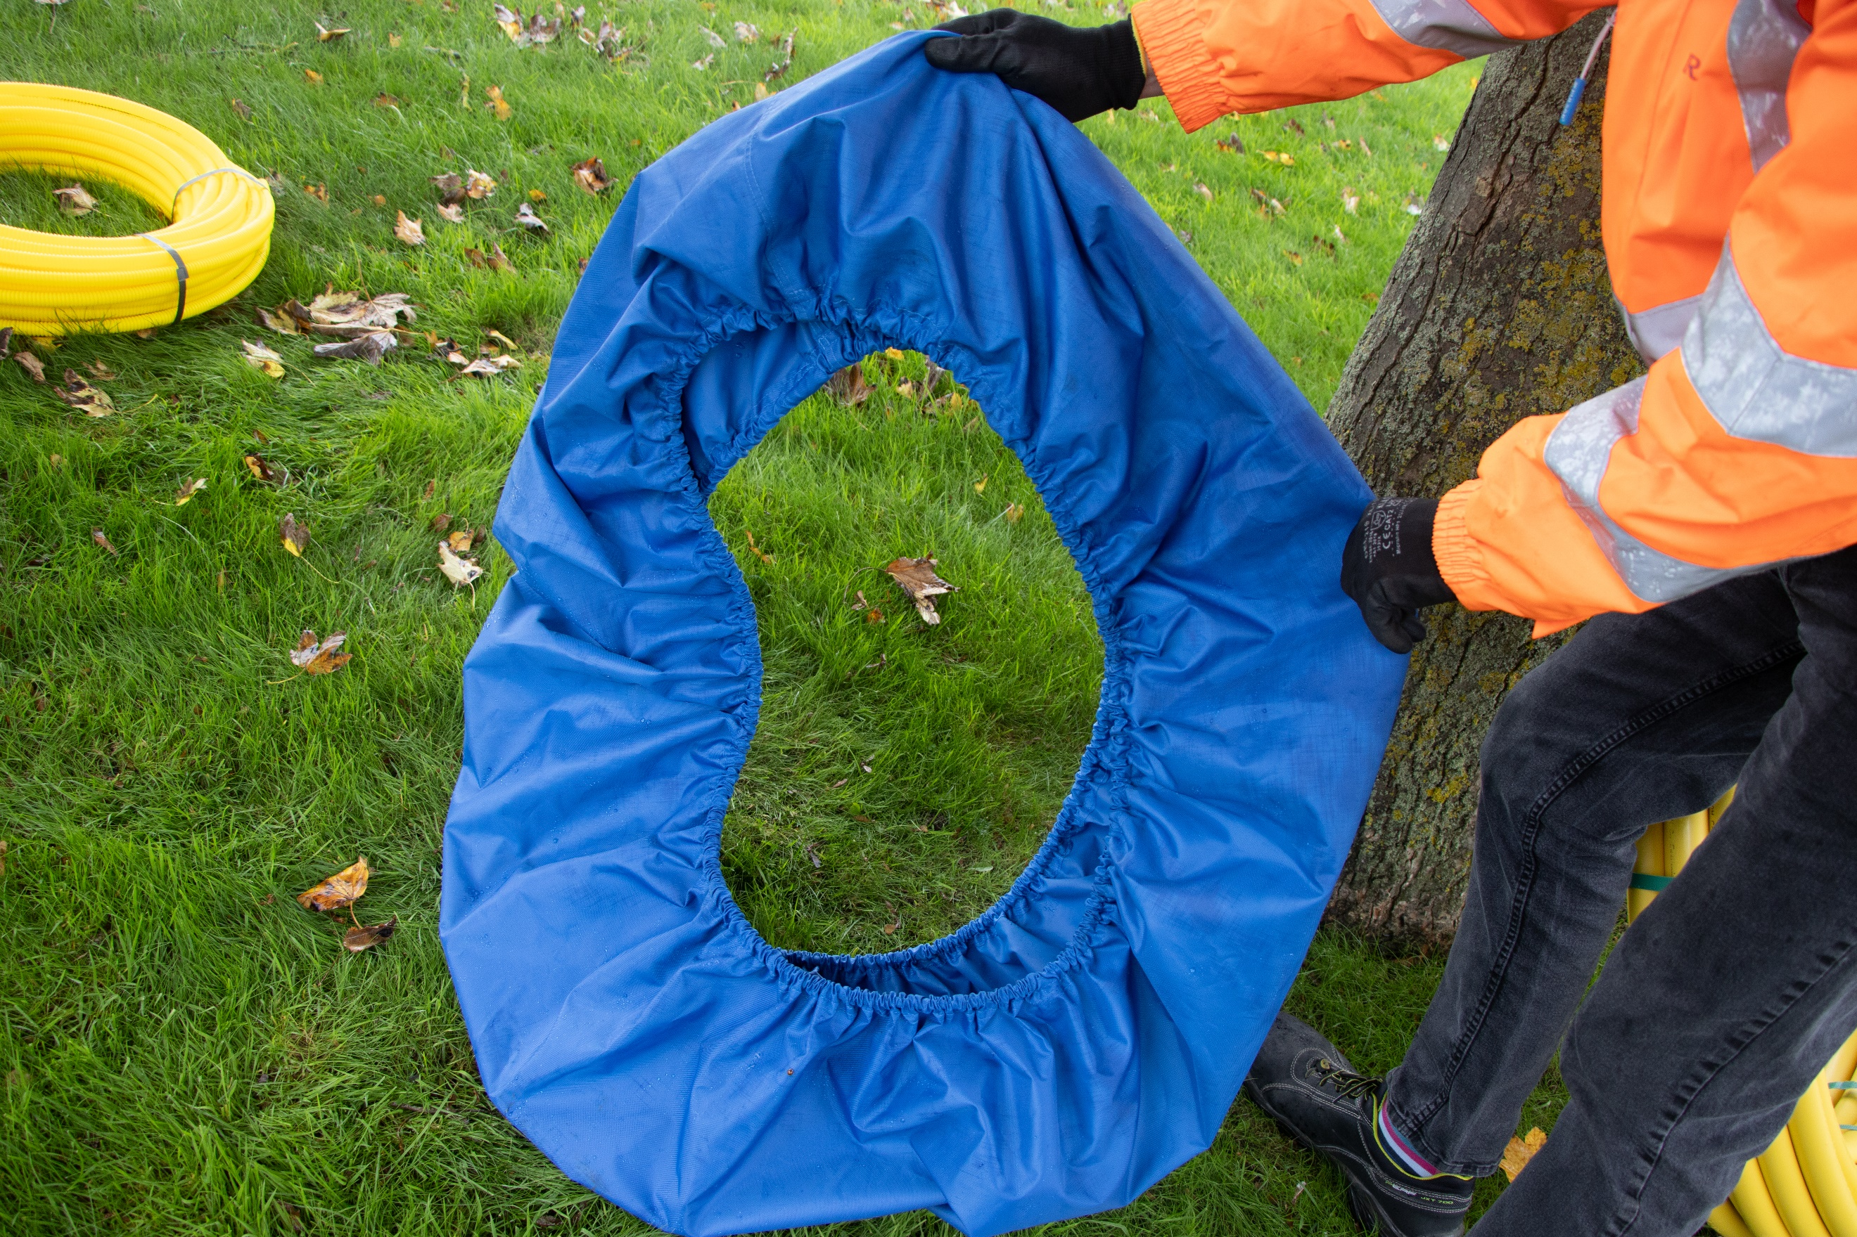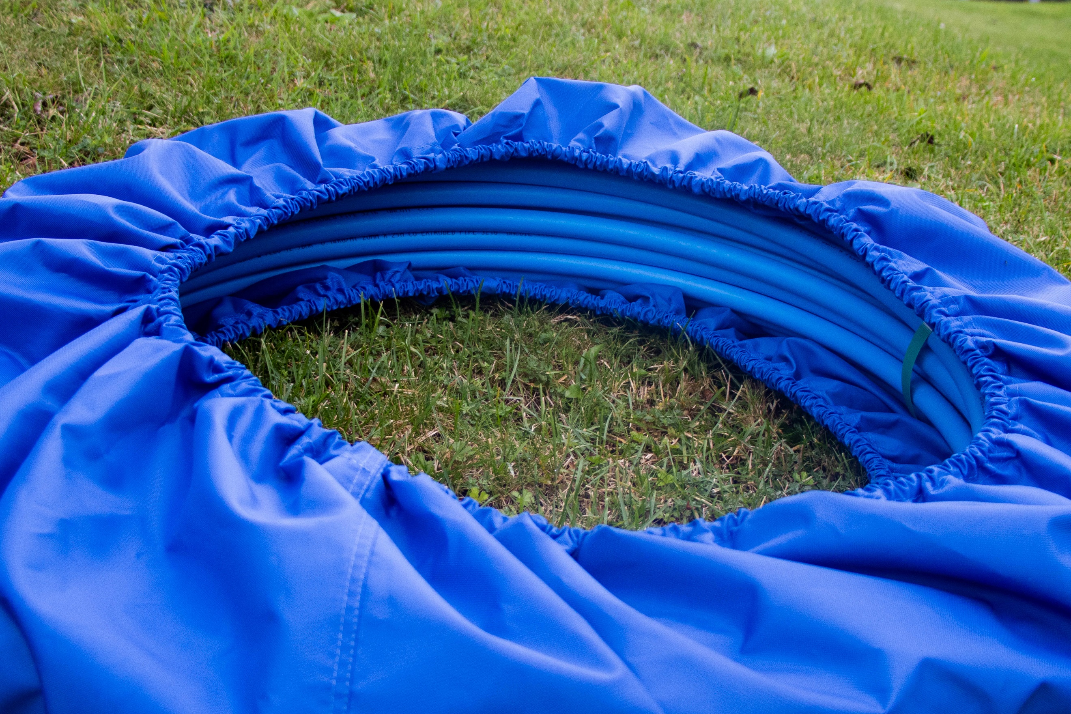

Image 1 & 2 – Coil dispensing bag and with coil located.

Available from Radius Systems, product code : FT0767

Mains pipes

Coiled pipes 50mm diameter and above should be dispensed from a coil trailer which contains suitable safety features that promote safe handling and dispensing of the coiled pipe, by trained and competent personnel. The coil trailer manufacturer or supplier should provide instructions on the correct use of the trailer for pipe dispensing.

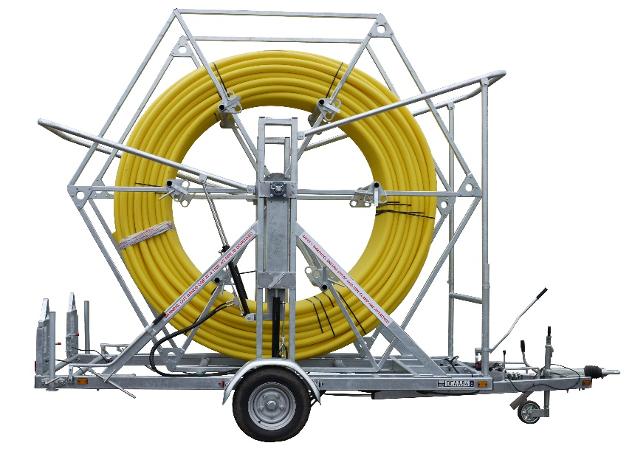

Radius Systems have provided some general guidance which should be read in accordance with the coil trailer suppliers instructions:

- PPE should be worn in accordance with the risk assessment. A hard hat, safety boots, gloves and safety glasses are recommended minimum safety wear.
- Ensure the coil trailer is suitable for the pipe diameter, SDR and coil dimensions.
- Ensure the coil trailer is in good working condition and has been checked as suitable by the supplier and pipe installation personnel at the point of handover.
- Ensure the coil suppliers instructions on loading the pipe safely into the trailer are adhered.
- Ensure the pipe coil is loaded in the correct orientation to be dispensed. The coiled pipe should contain direction arrows on the pipe to inform the loading process.
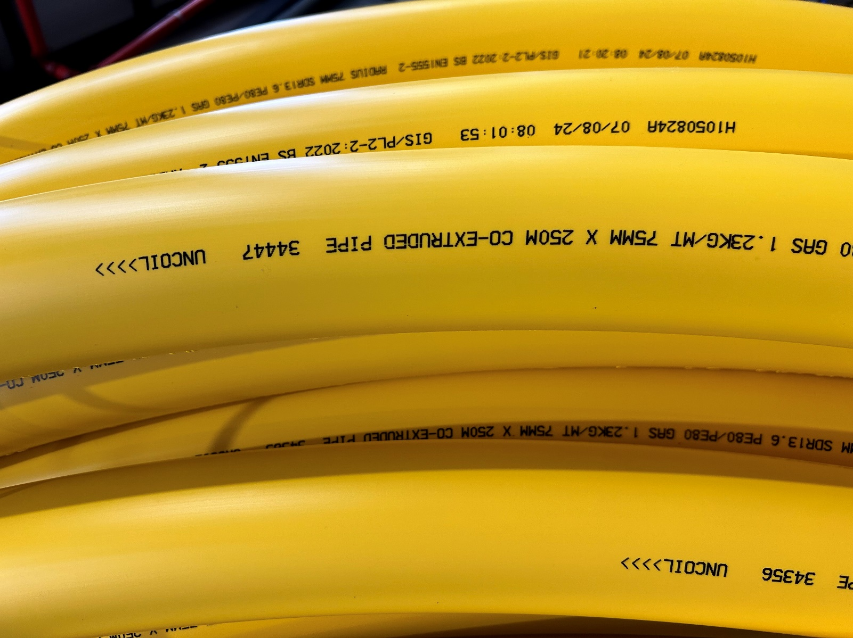

Image 3 – Pipe print-line indicates pipe uncoil direction

- Use webbing straps certified for the weight to be lifted, to lift coil pipes into the coil trailer.
- All loading and dispensing procedures should be carried out at ground level.
- Ensure the pipe is secured in the coil trailer ahead of dispensing, including securing the coil ‘tail end’ within the trailer.
- A competent person should be nominated to supervise the coil trailer operation.
- Only cut the pipe bands when the coil is stationary, as required when the pipe is dispensed from the coil trailer.
- The pipe banding should be cut using long reach, round nosed cutters that will not damage the pipe.
- Ensure the coiled pipe is dispensed in a controlled process.
- Ensure the coil dispensing trailer is cleared of any debris and prepared for the next coil or secured for onward transportation, as per the manufacturer’s instructions.
- If a part coil remains in the coil trailer after pipe installation, it must be safely secured before any onward transportation.

Document end

