Pipe print-line detail

Radius Systems Polyethylene (PE) pipes for Gas, Water and Wastewater applications are marked for identification and traceability. The markings appear on the pipe at 1m intervals in two distinct formats. The print-line is inkjet printed in a clear colour distinction from the pipe, for ease of identification and also embossed into the pipe surface for long term identification purposes.

It is expected that the inkjet print-line may be removed during certain installation and jointing practices, the embossed print-line is therefore more durable for lifetime identification.

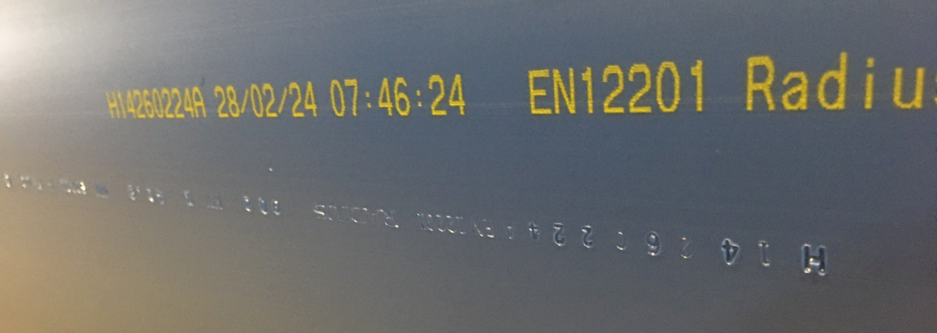

The print-line features the following information, which is contained in the examples
further below:-

- Production site, Extrusion line, Date
- Specification manufactured against and maximum operating pressure (bar)
- Manufacturer
- OD and wall thickness (minimum)
- SDR (Standard dimension ratio)
- Fluid application
- PE Material grade and pipe type
- Weight per metre
- Metre mark (from the start of batch)
- Uncoil direction (coiled pipe only)

The print-line example below was taken from a 90mm SDR11 Potable water pipe

H9 150724 18/07/24 10:39:30 EN12201 RADIUS 90mm x 8.2mm SDR11 W PE100 16BAR 2.13KG/MT Co-extruded pipe 1234 UNCOIL >>>>

H (Hilcote plant) 9 (Extrusion line 9) 150724 (Batch start date) 18/07/24 10:39:30 (Actual date and time hr:min:sec manufactured) EN12201 (Specification) RADIUS (Manufacturer) 90mm x 8.2mm (Dia x min wall thickness) SDR11 (SDR) W (Water application) PE100 (Material) 16 bar (Maximum operating pressure) 2.13 Kg/mt (Weight per metre) Co-Extruded pipe (pipe type) 1234 (batch metre mark) UNCOIL > > > > (Uncoil direction for pipe coils only)

Note 1: W/P on Black pipe, indicates suitability for water or wastewater applications.

Note 2: On gas pipes, the pipe is manufactured to two recognised specifications with differing pressure ratings due to the safety coefficients. Therefore, the pressure rating is not stated but can be advised by Radius Systems.

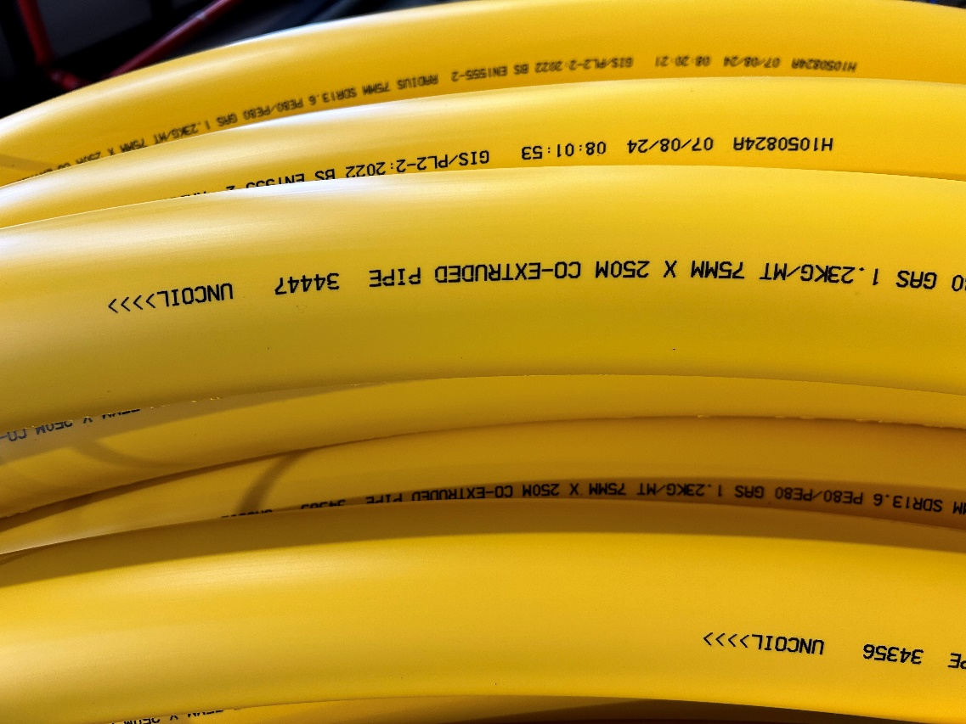
Example: Gas pipe legend detail on coiled pipe.

Document end.

